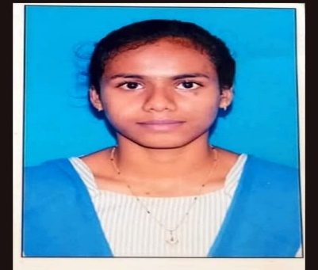***AMBATI LAKSHMI SRAVANI***

[9951316854|sravanireddy25771@gmail.com](mailto:9951316854|sravanireddy25771@gmail.com)

Front-End Developer|Web Developer

**Web Developer Intern**

A passionate Web Developer Intern with a drive to create exceptional user experiences through the use of HTML, CSS, and JavaScript. Seeking a position to leverage strong technical and problem-solving skills and extensive web development knowledge to achieve organizational efficiency, reduce page load speeds, and optimize user interfaces.

**WORK EXPERIENCE**

**Web Developer Intern**

15/07/2024 – Present

GeekBase Technology

* Developed a responsive website UI using HTML, CSS, and JavaScript that reduced overall page load speed by 15%
* Enhanced the usability of existing applications by applying the latest accessibility standards and best practices
* Collaborated with project managers to successfully deliver projects on time, resulting in an increase in organizational efficiency

**SKILLS & COMPETENCIES**

* HTML
* CSS
* JavaScript
* Responsive Design
* Web Development
* User Experience Design
* Accessibility Standards
* Project Management
* Collaboration
* Visual Design
* Functional Requirements Analysis
* UI Optimization
* User Research Analysis
* Proficiency code in html,html5,css,css3.
* Design Process Optimization techniques
* Excellent communication skills
* Enviroment friendly
* Maintain teamwork
* Web technologies

**Hard Skills**

* HTML/CSS/CSS3/HTML5/REACT.JS
* JavaScript
* Responsive Design
* Cross-Browser Compatibility
* Version Control (Git)
* Web Performance Optimization and emerging trends
* Attention to detailed and clean projects code reviews

**Education**

* Bachelors of Computer science in the stream of artificial intelligence and data science (2022-present)
* Completed intermediate in sri Veerisetty junior college with 96% in the MPC stream(2019-2021)
* Completed secondary education in the Viswasanthi high school with cgpa 9.7 in the year 2019.

**Languages**

English|Hindi|Telugu

**Internship and courses**

* Full stack development with MERN (MongoDB,Express.js,React.js,Node.js)Stack at Pace institute of technology and sciences
* Proficiency in python,c,java script frameworks.
* Proficiency code in html,html5,css,css3,php.
* Familiarity with version control systems such as GIT.

**Projects**

Project:

Created a e-commerce website by using html,css,java,bootstrap.

Description: My website name is HolidayTrip and I developed it for the tourists to book their tickets and enjoy their vacation through our services.Created an user-friendly web applications for users and maintain easily.

Git hub link of my project is: <https://github.com/22kq1a54d4/holiday-trip-website>